Case Study **Development of Restaro Service Using the SDLC Approach**



* Alok Ranjan (2022CSB091)
* Ranveer Kumar (2022CSB092)
* Karan Kumar (2022CSB093)
* Rajesh Kumar (2022CSB094)

**Case Study: Development of Restaro Service Using the SDLC Approach**

The development of Restaro Service, a top food delivery and restaurant aggregation platform, can be better understood by looking at how it moves through the Software Development Life Cycle (SDLC).

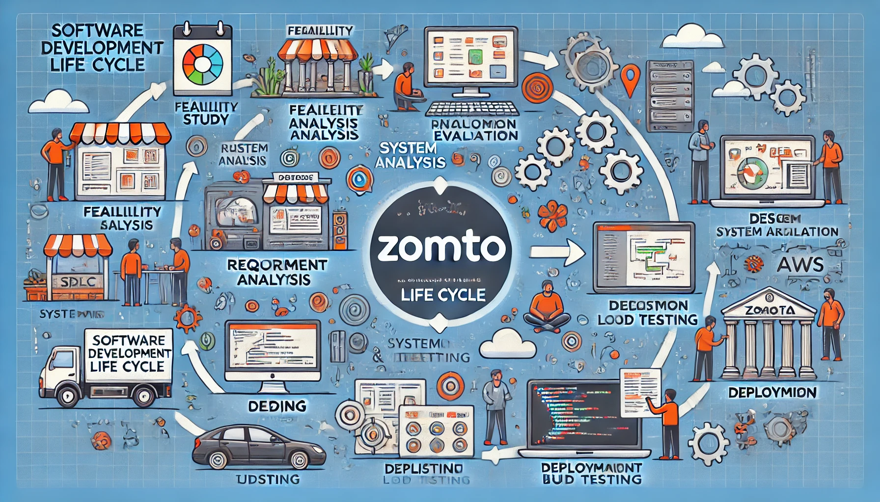

## **1. Feasibility Study**

**Objective**: Evaluate if launching the Restaro Service platform is feasible and if it can scale effectively.

**Execution**:

* + **Technical Feasibility**Can the platform handle a lot of users and easily connect with tools like tracking, maps, and payment systems?
  + **Economic Feasibility**Does the budget work, and can we earn enough from commissions, ads, and premium features like Restaro Service Pro?
  + **Operational Feasibility**Are employees ready, and can restaurants be onboarded smoothly to keep things running well?

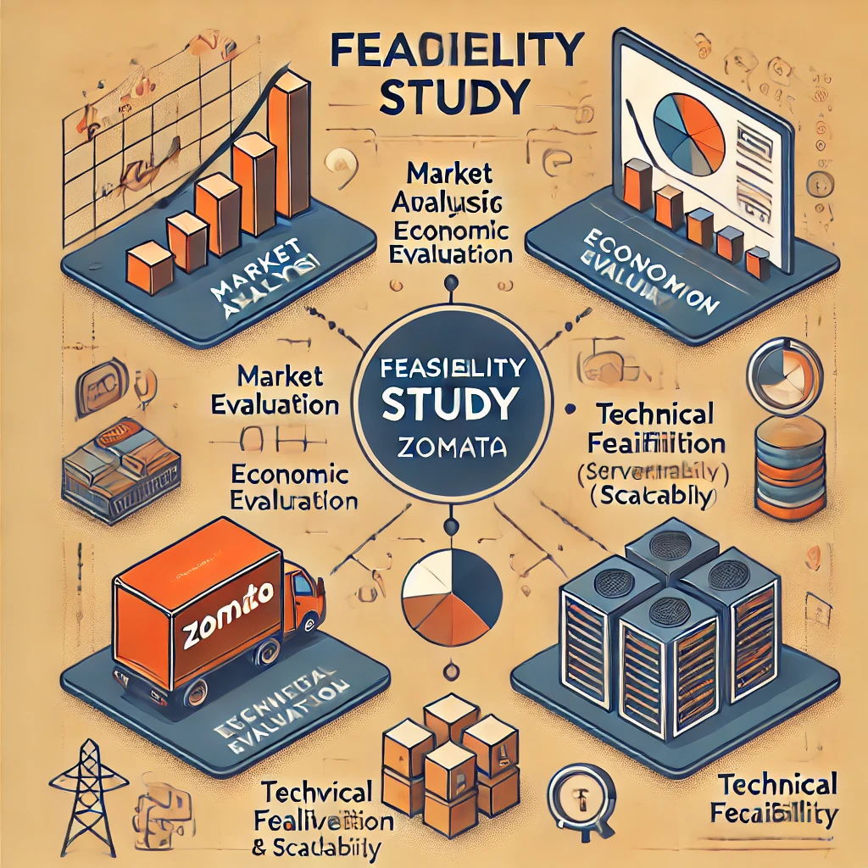

We haven't found any image for the feasibility section, so we used [**Leonardo.ai**](http://leonardo.ai) to generate one.

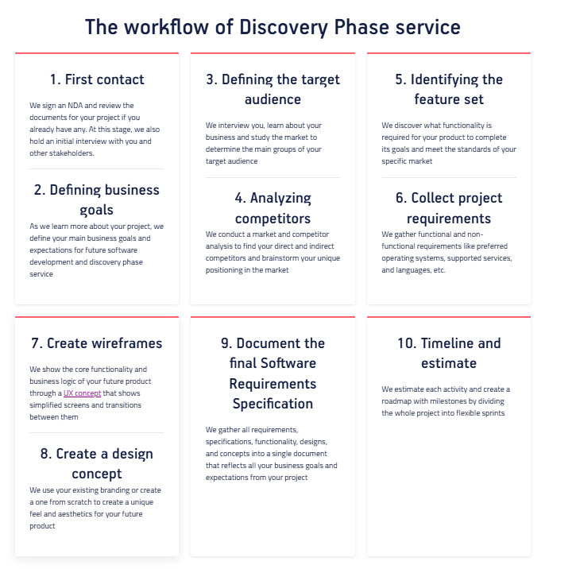

## **2. Requirement Analysis**

* **Objective**: Define all user and system requirements for the platform.
* **Execution**:
  + **Product Functions**:
    - Users should be able to search **restaurants, view menus, and place orders.**
    - Provide **real-time order tracking** and review options.
    - Include a **payment gateway** that supports multiple methods.
  + **Non-functional Requirements**:
    - Secure user data using encryption.
    - Ensure scalability for peak times.
    - Support cross-platform functionality (web, iOS, Android).

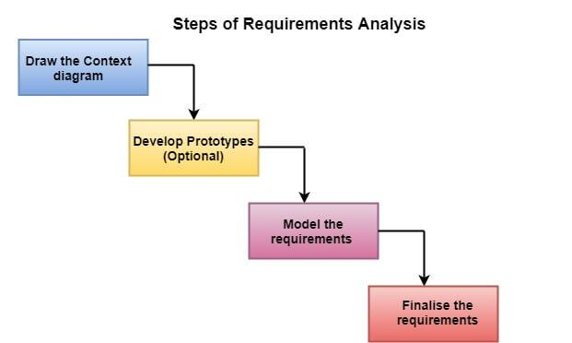

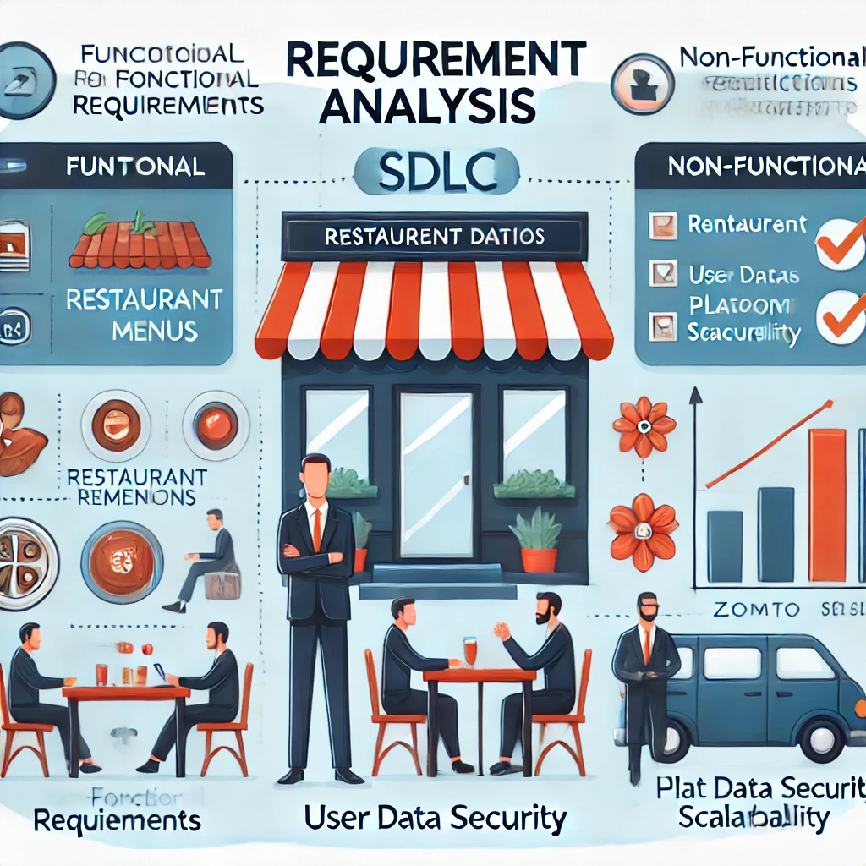

## **Requirements analysis techniques**

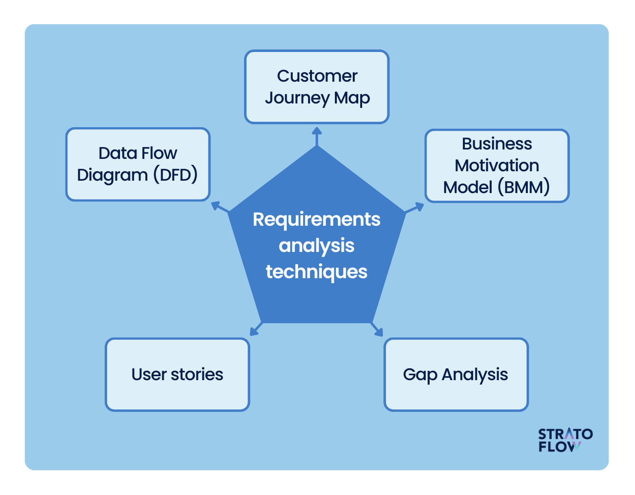

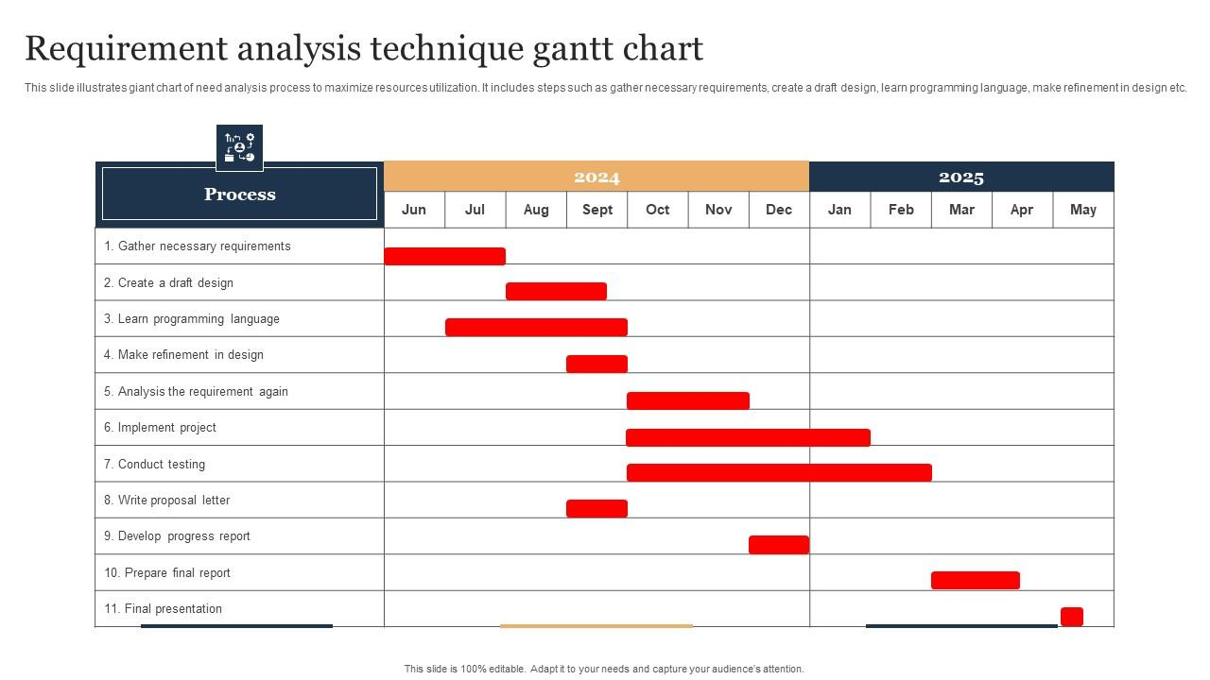

A visual representation of tasks along with their scheduled timelines. They help business analysts visualize the start and end dates of all the tasks in a project.

## **3. Design**

* **Objective**: Create a blueprint for how the platform will function and its architecture.
* **Execution**:
  + **Technical Feasibility**Can the platform handle a lot of users and easily connect with tools like tracking, maps, and payment systems?
  + **Economic Feasibility**Does the budget work, and can we earn enough from commissions, ads, and premium features like Restaro Service Pro?
  + **Operational Feasibility**Are employees ready, and can restaurants be onboarded smoothly to keep things running well?

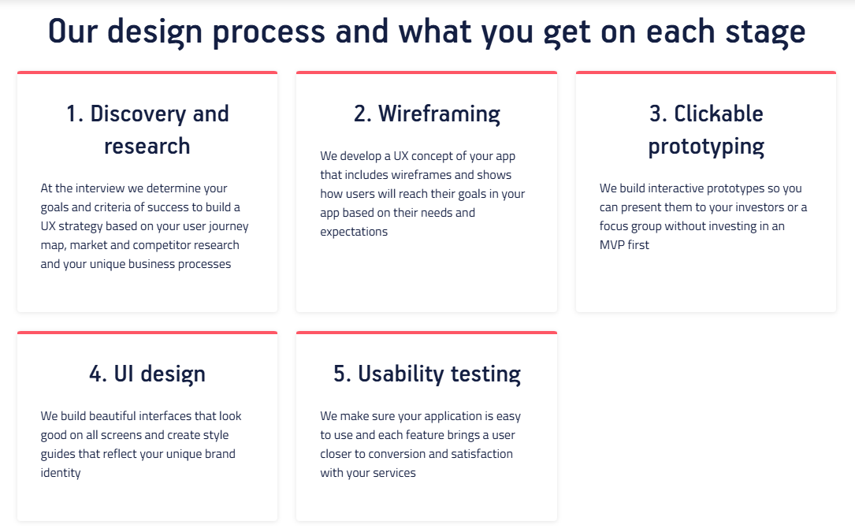

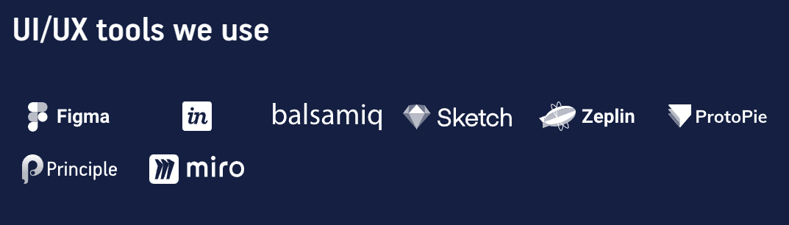

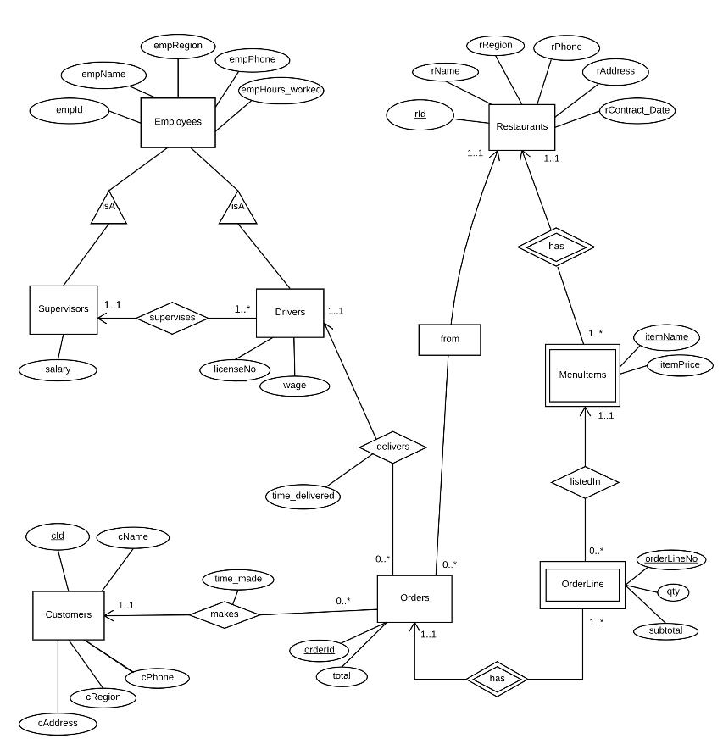

**Detailed Design(ER Diagram)**

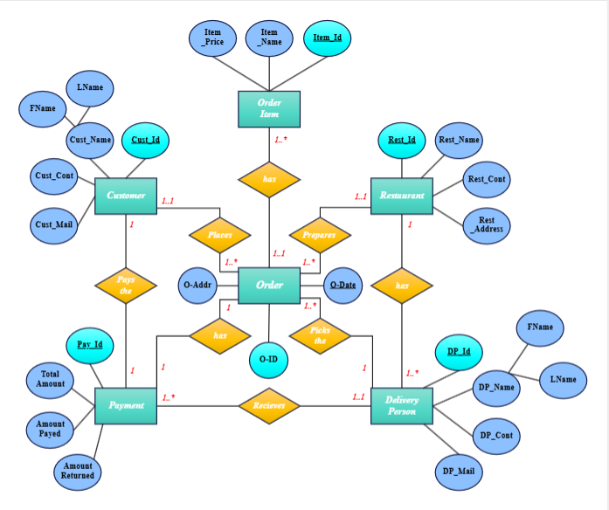

* 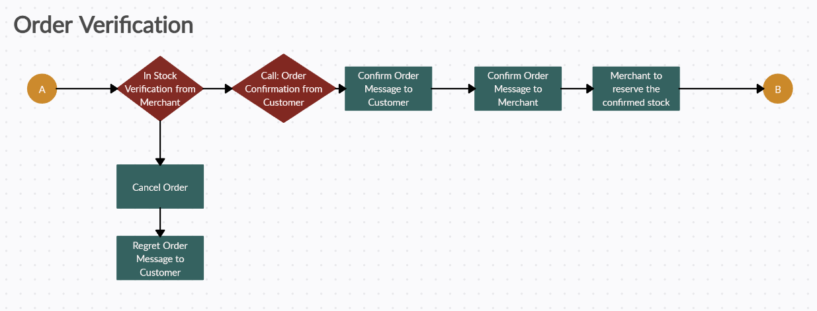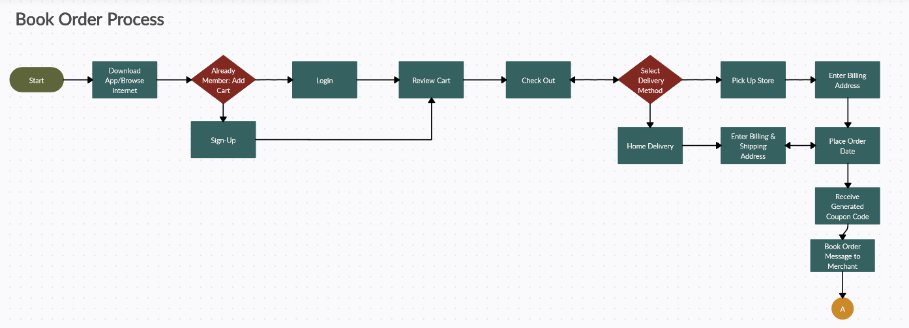

**Activity Diagrams** to understand the flow of programs at a high level

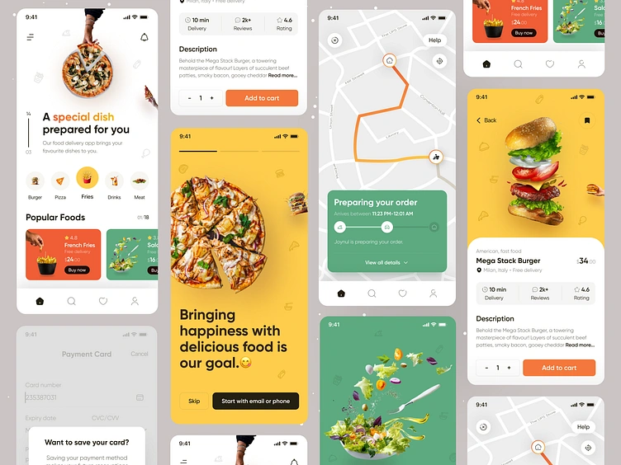

**UI Interface Diagrams**

## **4. Coding**

* **Objective**: Turn the design into actual working software using the appropriate technologies.

**Programming Languages**

* **Backend**: **Python (Django) and Node.js** for API development and business logic.
* **Frontend**: **React Native** for a responsive, cross-platform mobile app interface.

**Database**

* **Primary Database**: **PostgreSQL** for structured data like user profiles and orders.
* **Real-Time Tracking**: **MongoDB** for fast, dynamic updates of order statuses.

**Version Control**Use **GitHub** for efficient **code management, versioning, and team collaboration.**

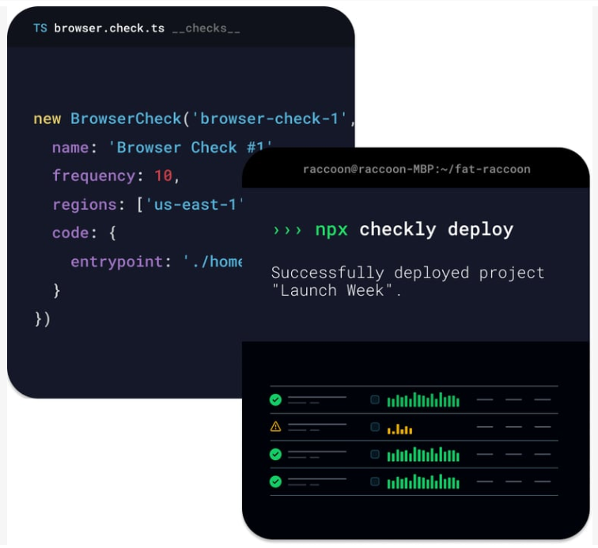

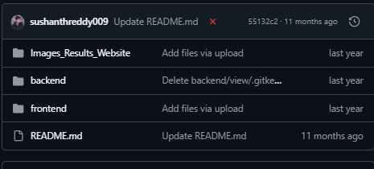

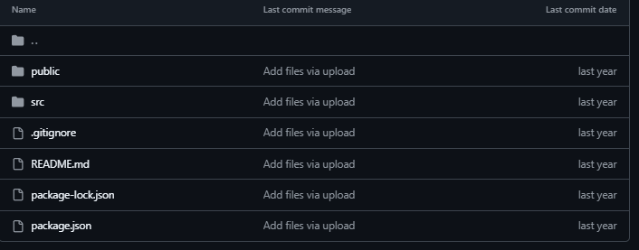

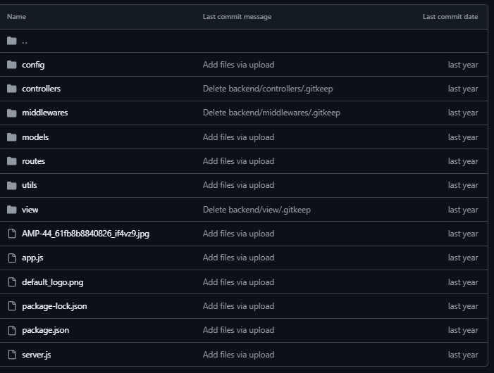

## **5. Testing**

**Key Points:**

* **Testing food delivery apps is crucial** to ensure a smooth user experience and identify bugs before they cause problems.
* **There are 7 important test cases** to cover the core functionalities of a food delivery app, including the home screen, search function, ordering process, cart functionality, login/registration, account section, and testing without logging in.
* **Different types of testing are essential** for food delivery apps, including functional testing, performance testing, usability testing, compatibility testing, and security testing.
* **To make a food delivery app successful**, focus on a user-friendly interface, diverse restaurants, reliable delivery, security, and continuous improvement.

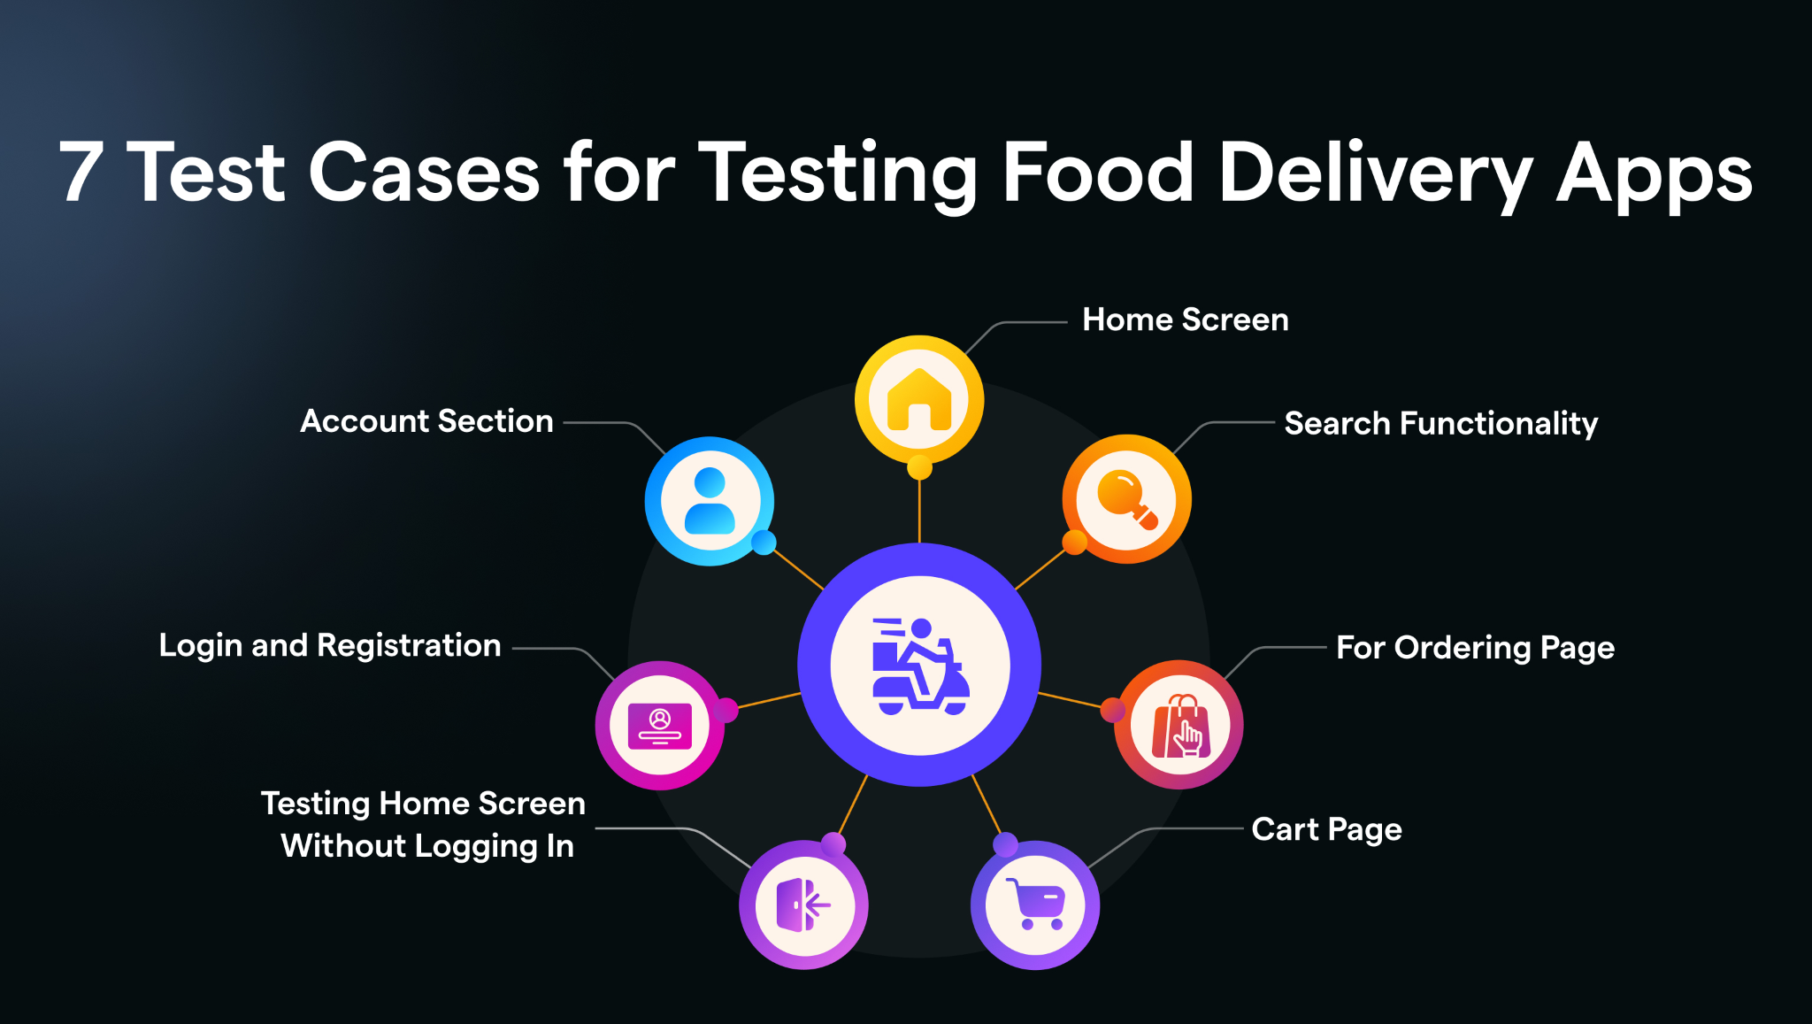**Test Case #1- Home Screen**

* Validate previous orders display.
* Verify accurate delivery location.
* Check restaurants listed by distance.
* Validate billing discounts visibility.
* Test filter options (cuisine, rating, delivery time, etc.).

### **Test Case #2- Search Functionality**

* Verify that the restaurant's name can be searched in the text box.
* Validate cuisine’s name is searchable in the search box.
* Validate that the search result matches with the keywords entered in the search box.

**Test Case #3- For Ordering Page**

* Verify cuisines offered under restaurant names.
* Check adding items to the cart.
* Confirm veg/non-veg markers (green/red dots).
* Validate delivery offers, modes, and timings.
* Test item customization and accurate pricing.
* Check filtered reviews and food ratings.

### **Test Case #4- Cart Page**

* Verify delivery location accuracy.
* Check selected items displayed correctly.
* Test deleting items, applying offers, and changing quantities.
* Confirm invoice generation and payment options.
* Ensure cart retains items after closure.

### **Test Case #5- Testing Home Screen Without Logging In**

* Verify location and restaurant display.
* Test filters and nearby restaurants visibility.
* Check food ordering without login.

### **Test Case #6- Login and Registration**

* Verify that users can log in to the food delivery application by entering a mobile number.
* Check that users can select delivery locations after a successful registration.
* Verify for failed user login.
* Verify for registration using an already existing mobile number.

### 

### **Test Case #7- Account Section**

* Validate order history, favorite orders, and address book.
* Check logout, feedback, and help options.
* Confirm OTP authentication works.
* **Objective**: Ensure the platform works reliably and performs well under different conditions.
* **Execution**:
  + **Unit Testing**Test individual modules like payment integration, search functionality, and user login to ensure they work as expected.
  + **Integration Testing**Validate how the ordering system interacts with third-party APIs, such as real-time tracking, to ensure seamless data flow.
  + **Load Testing**Simulate high traffic scenarios, especially during peak seasons, to assess system performance and identify bottlenecks.
  + **User Acceptance Testing (UAT)**Invite beta users to interact with the platform and provide feedback on its functionality, usability, and performance.

## 

## 

## 

## 

## 

## 

## **6. Deployment**

* **Objective**: Make the platform available to users.
* **Execution**:
  + **Cloud Hosting**Host the platform on AWS for scalable, reliable, and secure cloud infrastructure.
  + **Phased Rollout**Launch in one city first, then gradually expand to other locations based on user feedback and system performance.
  + **Monitoring**Utilize tools like New Relic to track uptime, monitor performance, and detect any issues in real-time.

## 

This is a deployment diagram for an online food ordering system. It shows how different components in the system interact and are deployed across various devices and networks.

### Key Elements Explained:

1. **System's Server:**
   * Hosts the database and backend logic of the online food ordering system.
   * Connects to other components via a Private Network (NW) and Inter Connection.
   * Stores critical data like user information, orders, and restaurant details.
2. **Online Food Ordering System:**
   * Represents the application or system running on a private network.
   * Acts as the bridge between customer devices, admin devices, and the server.
   * Handles business logic, processes user requests, and fetches/saves data from the server.
3. **Customer Device:**
   * Devices (e.g., smartphone, tablet, or browser) used by customers to place orders.
   * Communicates with the system through HTTP(S) (secure connection) via the browser or app.
4. **Admin's Device:**
   * Devices used by restaurant admins to manage orders, update menus, and track deliveries.
   * Connects to the system through a Private Network (NW) for enhanced security.
5. **Private Network (NW):**
   * Ensures secure communication between the server, system, and admin device.
6. **Inter Connection:**
   * Links the System's Server to customer devices and other components for data exchange.

### **Workflow:**

1. Customer Device: Initiates a request (e.g., searching restaurants, placing orders) via the browser or app over HTTP(S).
2. Online Food Ordering System: Receives the request, processes it, and interacts with the database on the System's Server.
3. Admin's Device: Manages updates and receives notifications about orders from the system via the private network.
4. System's Server: Stores and retrieves data as needed, ensuring all operations are synchronized across devices.

## **7. Maintenance**

* **Objective**: Continuously update and improve the platform over time.
* **Execution**:
  + **Bug Fixes**Regularly address bugs and system issues through timely updates and patches to maintain platform stability.
  + **User Feedback**Gather user insights via surveys and reviews to continuously refine the platform and enhance user experience.
  + **Feature Updates**Introduce new features like live tracking, contactless dining, and subscription-based discounts to keep the platform fresh and competitive.

## Cost of SDLC Maintenance

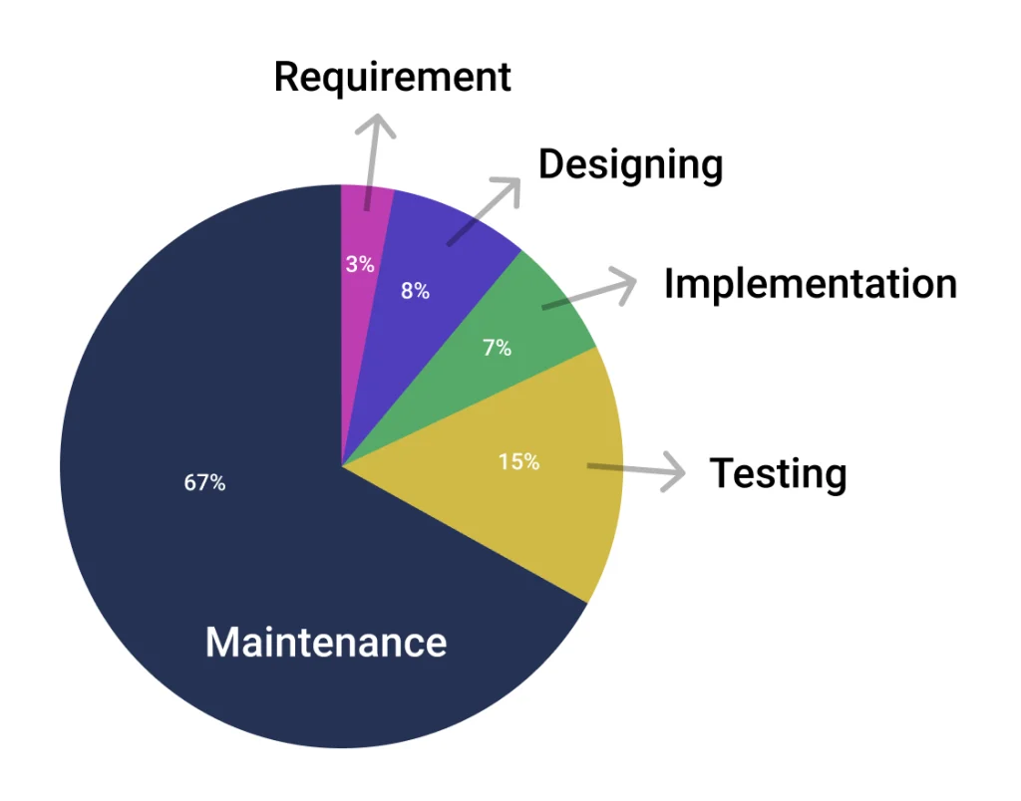

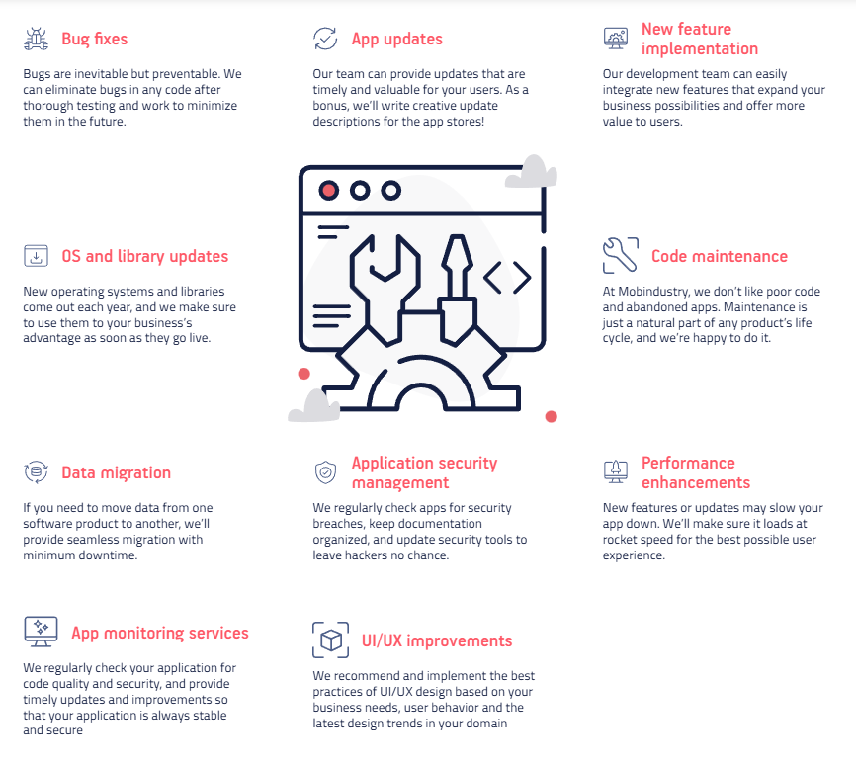

* 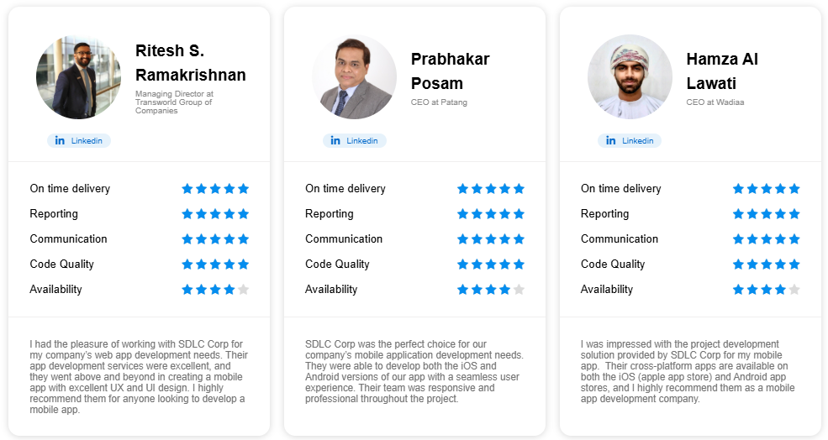

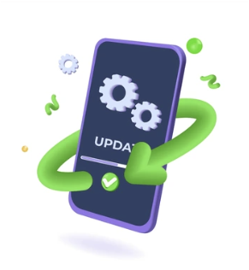

**References**

* **Feasibility Study**:  
  + [Understanding Feasibility Studies](https://www.javatpoint.com/feasible-study)
  + [Market Analysis for SDLC](https://www.geeksforgeeks.org/types-of-feasibility-study-in-software-project-development/)
* **Requirement Analysis**:  
  + [Software Requirement Analysis](https://www.techtarget.com/searchsoftwarequality/definition/requirements-analysis)
  + [SDLC Guide: Requirement Analysis in Software Engineering](https://stratoflow.com/requirements-analysis/)
* **Design**:  
  + [Design Phase in SDLC](https://www.geeksforgeeks.org/software-engineering-software-design-process/)
* **Coding**:  
  + [Best Coding Practices](https://www.javatpoint.com/software-engineering-coding)
* **Testing**:  
  + [Software Testing Basics](https://intellipaat.com/blog/types-of-software-testing/)
* **Deployment**:  
  + [Deployment Best Practices](https://internetdevels.com/blog/software-deployment-best-practices)
* **Maintenance**:  
  + [Types of Software Maintenance](https://www.cpl.thalesgroup.com/software-monetization/four-types-of-software-maintenance)